**Sprint-2**

|  |  |
| --- | --- |
| Date | 7 November 2022 |
| Team ID | PNT2022TMID08486 |
| Project Name | Industry-Specific Intelligent Fire Management System |

**MONITORING SENSOR VALUES**

# Display the temperature values in the dashboard:

Submitted by: Rishalin,Rajasushmitha,Ramya,Sajitha chandran

Student Roll number:810419106050,810419106043,810419106046,810419106053

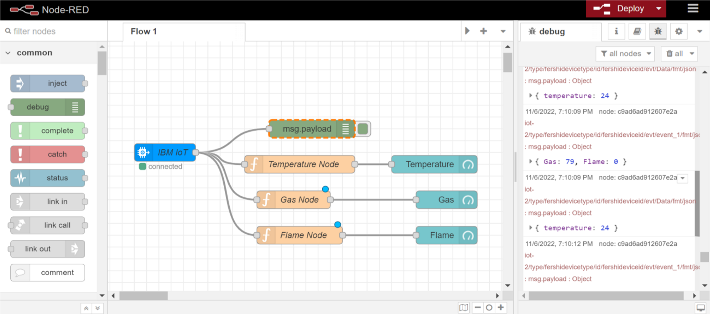

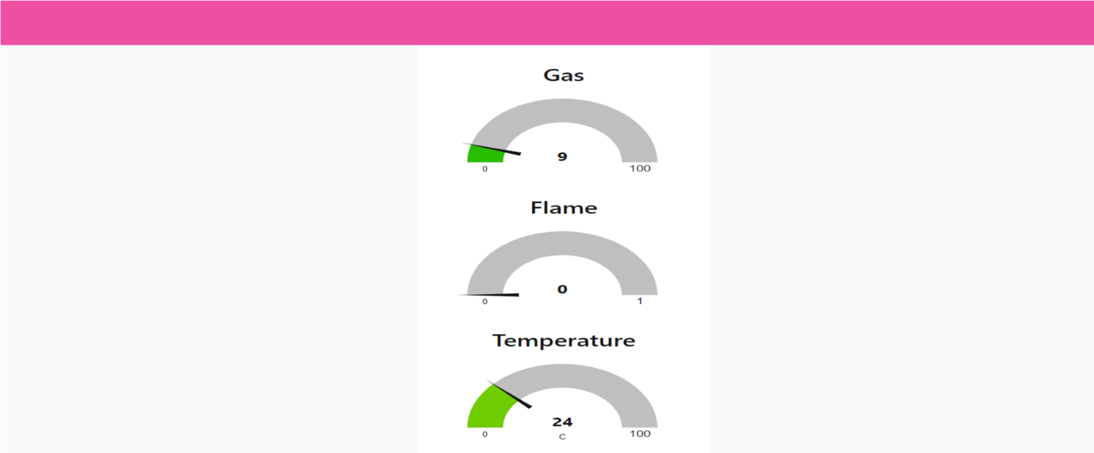

# Displaying flame sensor values:

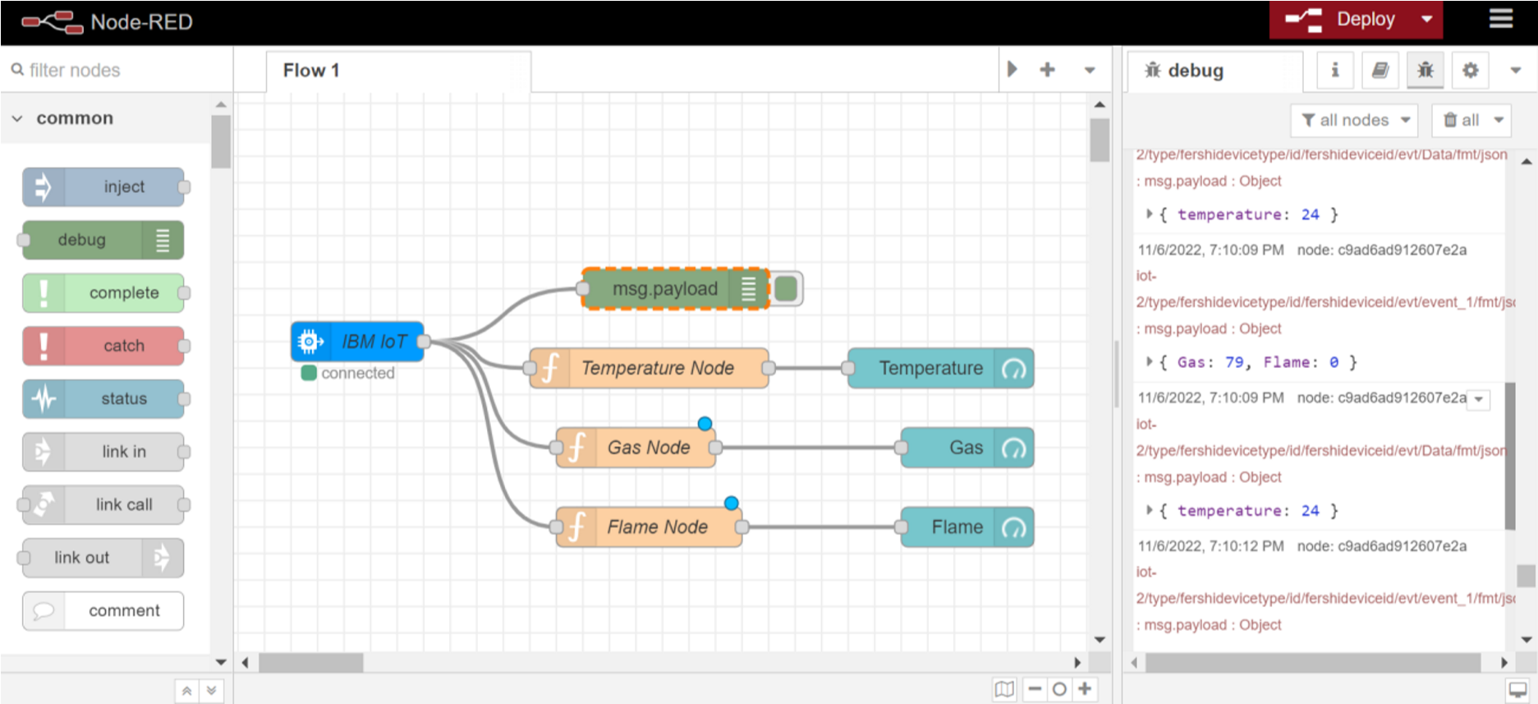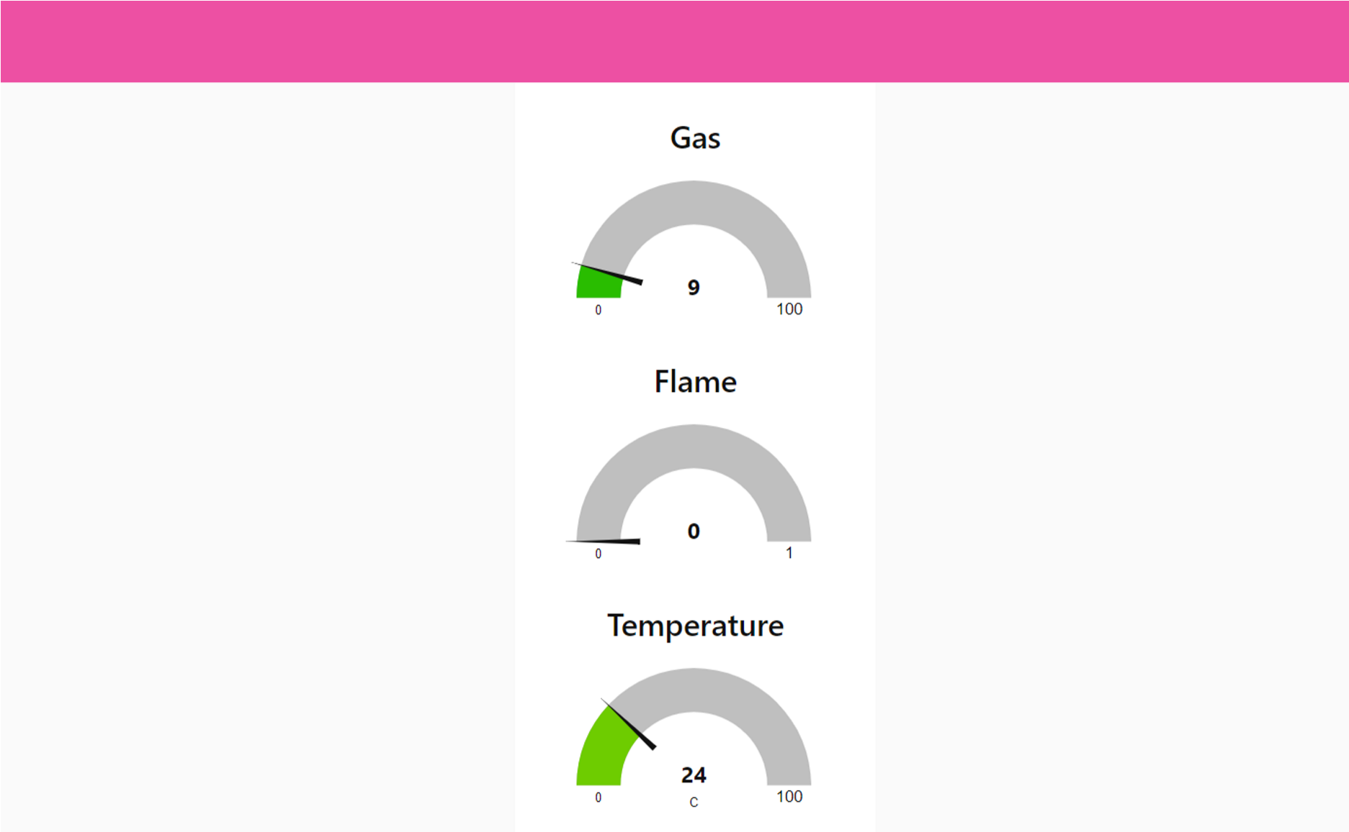

# Displaying gas sensor values:

